PAST EVENTS
4th Annual Food Giveaway
Tuesday, 19 December 2023
Sponsors: Paul Quinn College & Heroes, Cops and Kids
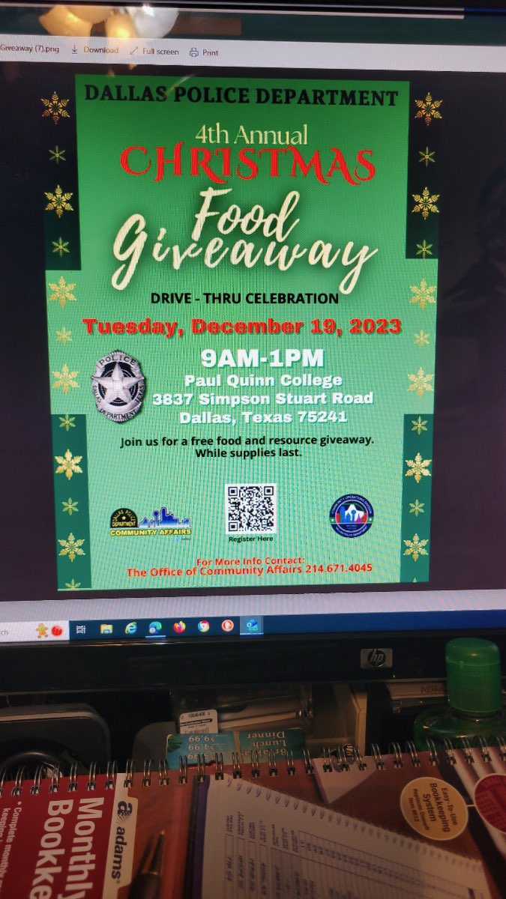
Christmas Workshop
Saturday, 16 December 2023
Sponsors: Sofia Lumen & Heroes, Cops and Kids

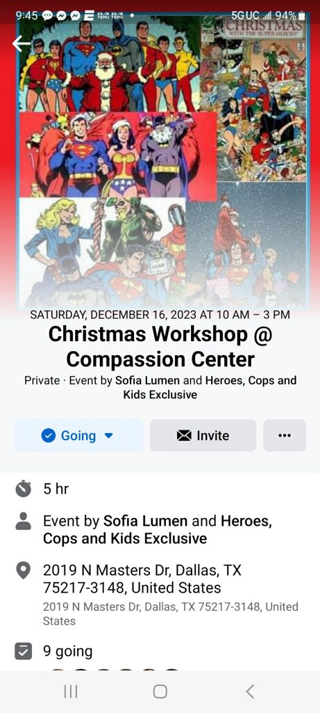
Blossoming Butterflies
3rd Annual Event
Sponsor: Oils 4Us
Saturday, 11 February 2023
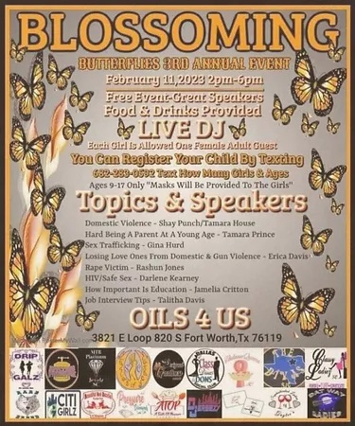

Destiny Church

Founders' Day Celebration

18 December 2022

Speaker: Pastor Jason White

Faith Tabernacle Christian Church

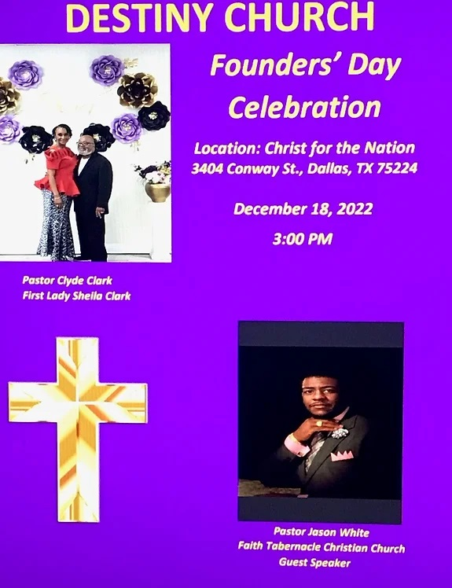

Temple of Hope, Faith & Grace Founders Day

​WHEN: OCTOBER 09, 2022

Speaker: Elder April Campbell

